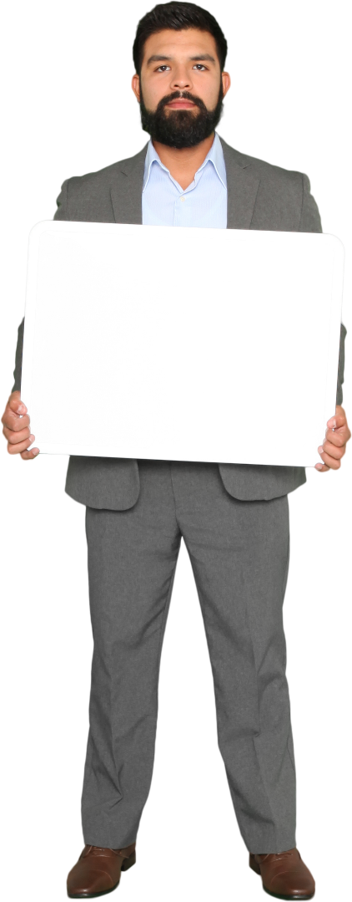
POETRY COMPETITION 2026
WYONG WRITERS GROUP

DETAILS OF COMPETITION
Free Verse
- GENRE FREE VERSE
- Closing Date 26/09/2026
- Maximum 1 entry per member of Wyong Writers Group
- Entries to be submitted to (Convenor Michael) in Word Format 12 Point font , Maximum 60 lines and double spacing by email to zhetto2011@yahoo.com.au
- Attach separate page in email - Name of author, Phone Number, Email address, Title of poem and
Confirming No use of AI (artificial Intelligence) - YES and
OWN WORK- YES
- Paper entries to be submitted with approval of Michael Convenor by 26/09/2026
- Winner to be announced on 24/10/2026 Judges decision is final

